PICTURE | SIZE | QUANTITY
 | 26 cm | 2300
 | 21 cm | 5400
 | 17 cm | 2700
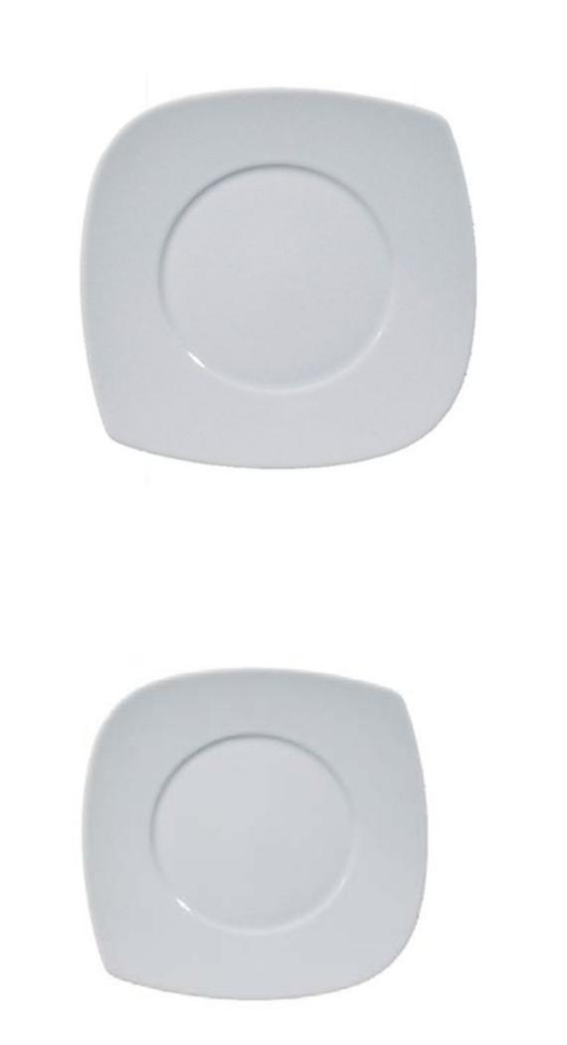
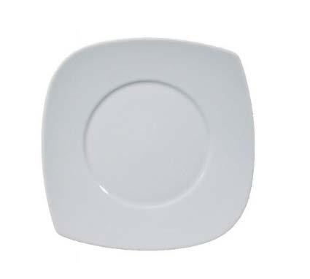
10400

CERTIFICATIONS:

Reg. CE 1907/2006: "REACH"

Reg. CE 2023/2006

Reg. CE 31/2005

Reg. CE 1935/2004

Reg. CE 95/2001
Directive 84/500/CEE DM 34/73

